ITA0305- Mobile Computing
LAB EXPERIMENT
Name: G.Ganesh
Reg NO:192373008

15. Design a dashboard displaying network performance metrics.

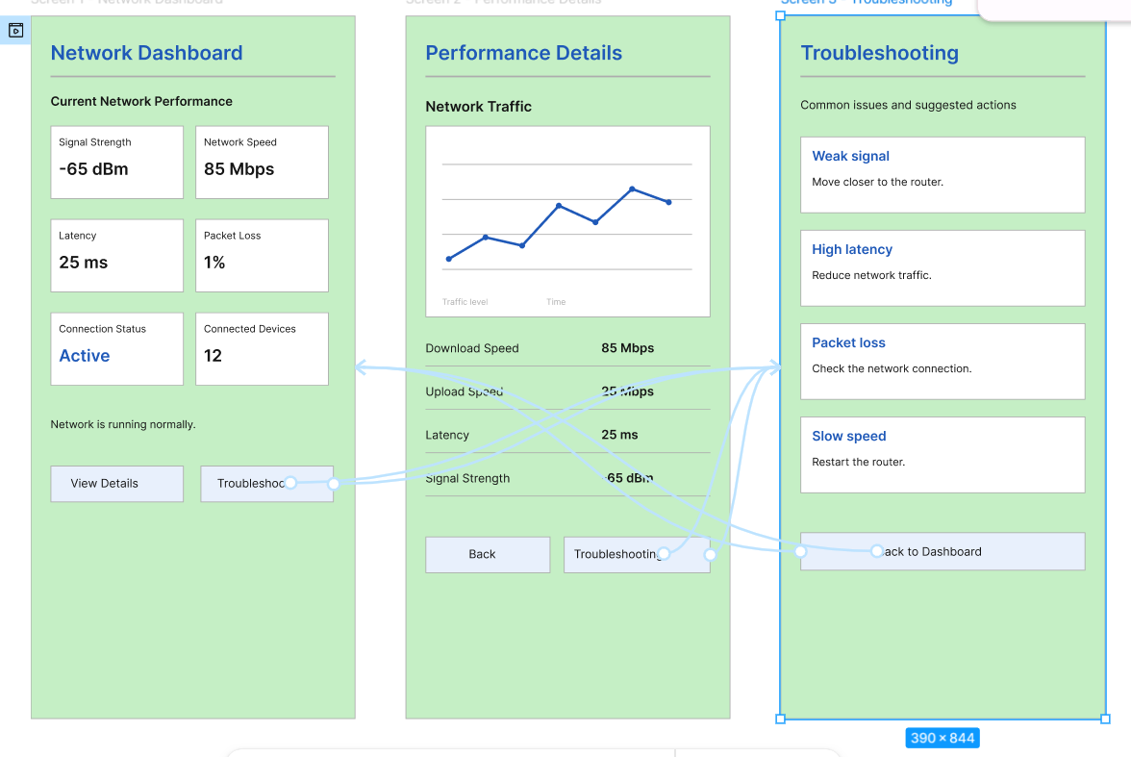

https://www.figma.com/design/hh3aaakb3ZE8ReSKuVZZOG/program16?node-id=3-4&t=8YykwQ0xgWvylqYK-0

